#### DETECTION OF GLAUCOMA USING IMAGE PROCESSING USING DEEP LEARNING

By

VIGNESHWARAN V 412420104144

SHENA REDDY P 412420104123

SUJAIRAM M 412420104130

Under the Guidance of

**Mrs.SUGANYA R**

* Department of Computer Science and Engineering

Sri Sai Ram Institute of Technology,

Chennai, Tamil Nadu, India

**PROJECT ID:IT2021CSPJ18**



## PROBLEM STATEMENT

* Glaucoma is one of the leading causes of blindness for people over the age

of 60. It can occur at any age but is more common in older adults.

* It is a prime sickness that damages the optic nerve of the eye and it additionally results in everlasting vision loss.
* We have come up with an efficient technique for the prediction of glaucoma

in the early stages using Photo Segmentation technique.



## SDG GOAL

SDG Goal: #3 Good Health and Well-being

* The aim of SDG goal 3 is to ensure good well-being health for all,

and gradually decreasing the most common preventable diseases.

* In this project, we were detecting the glaucoma in early stages to overcome

the difficulties.

### ABSTRACT

* Retinal photograph evaluation is comprehensively hired in the clinical area for the recognition of abnormalities in the eye.
* In this proposed methodology, we are predicting Glaucoma in the early stages using Exploratory Data Analysis (EDA), ResNet50 algorithm with minimum time consumption.



### EXISTING SYSTEM AND LIMITATIONS

* In the existing project, the accuracy level is not higher and it also consumes much time in accordance of many algorithms were used for detecting glaucoma.
* We’re addressing this by introducing an automated approach for optic disc

### ratio using image segmentation.

### PROPOSED SYSTEM AND ADVANTAGES

* Our proposed system focuses on automating the extraction of optic cup and optic disc ratio through pixel based segmentation.
* The Photo Segmentation technique is used to minimize the time consumption with better result.

# LITERATURE SURVEY

|  |  |  |  |  |  |
| --- | --- | --- | --- | --- | --- |
| **S no** | **Title** | **Name Of The**  **Author** | **Name Of the Journal and year** | **Work/ Algorithm carried Out** | **Drawbacks** |
| 1 | “Automatic Glaucoma Diagnosis Based on Photo Segmentation with Fundus Images”, | P. M. Siva Raja,  R. P. Sumithra,  G. Thanusha | IEEE Journal of Biomedical and Health Informatics, 2022. | Evaluation of retinal images | Expensive in terms of time and memory |
| 2 | Detection of Optic Disc and Cup from Color Retinal  Images for Automated Diagnosis of Glaucoma | Megha Lotankar, Kevin Noronha, Jayasudha Koti | IEEE UP  Section Conference on Electrical Computer and Electronics (UPCON) 2021. | Extraction of vertical disc and cup-ratio. | Doesn’t work well with non-globular clusters. |

LITERATURE SURVEY

|  |  |  |  |  |  |
| --- | --- | --- | --- | --- | --- |
| **S no** | **Title** | **Name Of The**  **Author** | **Name Of the Journal and year** | **Work/ Algorithm carried Out** | **Drawbacks** |
| 3 | Automated Diagnosis of Glaucoma Using Empirical Wavelet Transform and Correntropy Features Extracted from Fundus Images | Shishir Maheshwari, Ram Bilas Pachori, and U. Rajendra Acharya | IEEE Journal of Biomedical and Health Informatics, 2021. | Emprical Wavelet transform used for decompose the image. | Expensive in terms of time and memory |
| 4 | Detection of Optic Disc and Cup from Color Retinal Images for  Automated Diagnosis  of Glaucoma | Megha Lotankar, Kevin Noronha, Jayasudha Koti | IEEE UP  Section Conference on Electrical Computer and Electronics (UPCON) 2021 | Extraction of vertical disc and cup-ratio. | Doesn’t work well with non-globular clusters. |

# LITERATURE SURVEY

|  |  |  |  |  |  |
| --- | --- | --- | --- | --- | --- |
| **S no** | **Title** | **Name Of The**  **Author** | **Name Of the Journal and year** | **Work/ Algorithm carried Out** | **Drawbacks** |
| 5 | Automated Diagnosis of Glaucoma Using Empirical Wavelet Transform and Correntropy Features Extracted from Fundus Images | Shishir Maheshwari, Ram Bilas Pachori, and U. Rajendra Acharya | IEEE Journal of Biomedical and Health Informatics, 2020. | Emprical Wavelet transform used for decompose the image. | Expensive in terms of time and memory |
| 6 | Detection of Optic Disc and Cup from Color Retinal Images for  Automated Diagnosis  of Glaucoma | Megha Lotankar, Kevin Noronha, Jayasudha Koti | IEEE UP  Section Conference on Electrical Computer and Electronics (UPCON) 2020 | Extraction of vertical disc and cup-ratio. | Doesn’t work well with non-globular clusters. |

## ARCHITECTURAL DIAGRAM

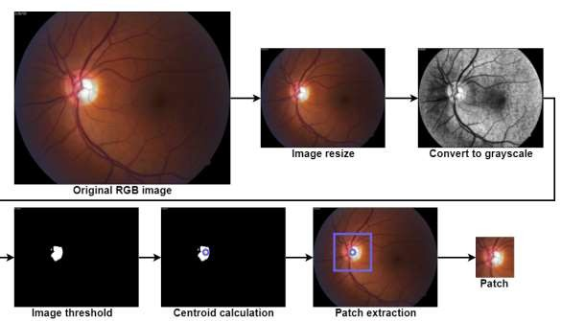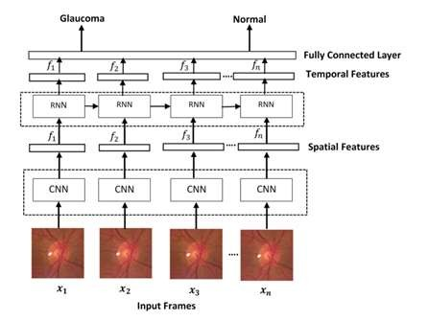

# 

The datasets consists of 30000 sample images extracted from Kaggle.

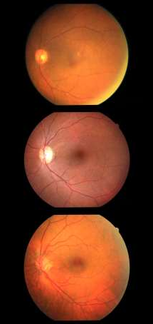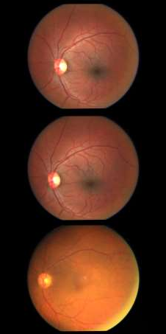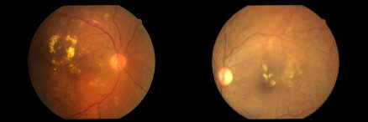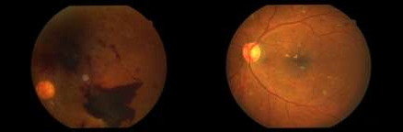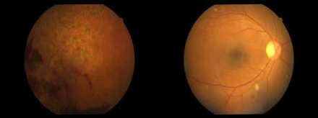

|  |  |  |  |
| --- | --- | --- | --- |
| **NORMAL IMAGE** | | **AFFECTED IMAGE** | |
|  |  |  |  |
|  |  |  |  |
|  |  |  |  |
|  |  |  |  |
|  |  |  |  |
|  |  |  |  |
|  |  |  |  |
|  | | | |

## LIST OF MODULES

* + - Preprocessing
    - Extracting Region Of Interest (ROI)
    - Feature Extraction
    - Classification

## MODULE DESCRIPTION

#### Preprocessing

* Data preprocessing is a process of preparing the raw data and making it

suitable for a machine learning model. It is the first and crucial step while

creating a machine learning model. When creating a machine learning project, it is not always a case that we come across the clean and formatted data.

* In the preprocessing method, the input image validation is done Exploratory

Data Analysis (EDA).

**Extracting Region of Interest(ROI)**

* A Region of Interest (ROI) is a portion of an image that you want to filter or operate on in some way. You can represent an ROI as a binary mask image. In the mask image, pixels that belong to the ROI are set to 1 and pixels

outside the ROI are set to 0.

* In this project, ROI extraction is used for detecting glaucoma on specific

regions instead of checking whole image.

* After extracting ROI, then brightest spot in the retinal image is calculated.



## Feature Extraction and Classification

* + Feature extraction is the process of transforming raw data in to numerical features that can be processed while preserving the information in the original data set.
  + U-Net algorithm is used for feature extraction.
  + Classification is a process of categorizing a given data in to classes, it can

be performed on both structured or unstructured data.

* + Classification is done to classify glaucoma. The ResNet50 algorithm is used

for classification.

* + Classification is done for better accuracy and early detection of glaucoma.

## CONCLUSION & FEATURE ENHANCEMENTS

* + In this paper, we used various methods for detecting glaucoma in the early stage with a good accuracy rate. The actual visualization is implanted in Matplotlib to display the defected image.
  + In this paper, we used the CDR model for detecting glaucoma in the earlier

stage. If we did not check in the earlier stage, the CDR value increases

periodically as age increases.

* + If the CDR value goes higher the possibility of glaucoma also increases.
  + This project gives the Detection of Glaucoma based on only the Optic Cup

to Disk rate management. Diabetics patients are mostly affected to

Glaucoma rather than normal person. Our future work is based on Analysis

of Glaucoma on Diabetic retinopathy.



## REFERENCES

1]. José E. Valdez-Rodríguez , Edgardo M. FelipeRiveron, Hiram Calvo – “Optic Disc Pre processing for Reliable Glaucoma Detection in Small Datasets”, MDPI,2022.

[2]. P. M. Siva Raja, R. P. Sumithra, G. Thanusha – “Automatic Glaucoma

Diagnosis Based on Photo Segmentation with Fundus Images”, IEEE, 2021.

[3]. Wyoming Tina Song, Ing-Chou Lai, Yi-Zhu Su - “A Statistical Robust Glaucoma Detection Framework Combining Retinex, CNN, and DOE Using Fundus Images, IEEE,2021.

[4]. Sudeshna Pattanaik, Subhasikta Behera, Pratyusa Kumar Dwibedy, Santhosh Kumar Majhi, Rosy Pradhan – “AdaRes: ResNet50 with AdaSwarm for Glaucoma Classification & Detection”, IEEE, 2022.

## REFERENCES

[5]. Kavya N, Dr. Padmaja K – "Glaucoma Detection Using Texture

Features Extraction”, Asilomar, 2017.

[6]. Esther Gyimah, Delali Kwasi Dake – “ Using Decision Tree Classification Algorithm to Predict Learner Typologies for Project Based Learning", IEEE, 2019.

7]. Afolabi O. Joshua, Gugulethu MabuzaHocquet, Fulufhelo V. Nelwamondo – “Assessment of the Cup-to-Disc ratio method for Glaucoma detection”, IEEE,2020.

[8]. Bajwa, M.N. Malik, M.I. Siddiqui, S.A. Dengel, A. Shafait, F. Neumeier, W.; Ahmed, S. Two-stage framework for optic disc localization and glaucoma.

## Paper Presentation Certificate

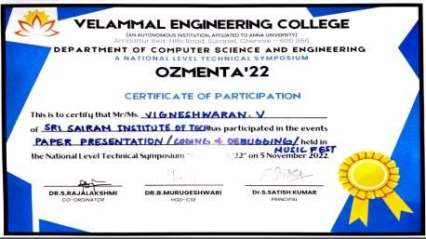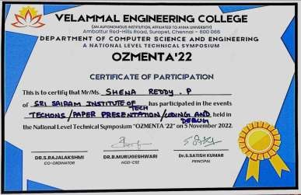



THANKYOU